Swinburne University of Technology


COS30019

Introduction to Artificial Intelligence

Assignment 1
AI Assistance on Personalized Learning

Author : Truong Ngoc Gia Hieu
Author ID: 105565520
Lecturer: Mr. Quang Chiem
Due Date: ${\text{1}}^{\text{st}}$ March, 2026
Submission Date:
Word Count:
Table of Contents

Part A: Abstraction 4
1.1 Assignment Requirements 4
1.2 Problem Statement 4
Part B: The Landscape and Revolution of AI 5
2.1 The Big Picture: What is AI? 5
2.2 The Profound History 6
2.3 The Stunning Revolution 8
2.4 Current AI Trends .9
2.5 Future of AI .9
Part C: Ethics and Application in AI-Driven Education .9
3.1. AI Ethics in General .
3.1.1 Core Ethical Pillars .
3.1.2 The Hidden Logic
3.2. Application of AI Ethics in Education .
3.2.1 AI Ethics in Education .
3.2.2 Academic Integrity and The "Cheating" Boundary
3.2.3 The Digital Divide .
3.3. Personalized Learning via AI Assistant .
3.3.1 Thinker Partner and Answer Engine .
3.3.2 AI Enhanced Self-Mastery
3.3.3 The "Desirable Difficulties" Principle .
3.3.4 Case Example .
3.4. Challenges and Obstacles .
3.4.1 Cognitive Atrophy .
3.4.2 The Illusion of knowledge
3.4.3 Fake Facts and Passive Acceptance .
3.3.4 The Erosion of Human Agency .
3.5. Solutions: Shaping a Responsible AI Future .
3.5.1 Technological Solutions .
3.5.2 Educational and Human Solutions
3.5.3 Policy and Ethical Frameworks .
Part D: Conclusion .
Part E: Acknowledgements
Part F: References .

Part A: Abstraction
  - Assignment Requirements
The unit Introduction to Artificial Intelligence aims to provide students with broad knowledge of algorithmic problem solving and basic concepts of Artificial Intelligence (AI). After finishing this fascinating course, students are expected to explain fundamental concepts, identify ethics and frameworks, and design innovative ideas that implement these algorithms. Additionally, the first assignment requires students to document a comprehensive research report focusing on AI Ethics and Responsible AI based on provided materials including slides and books.
  - Problem Statement
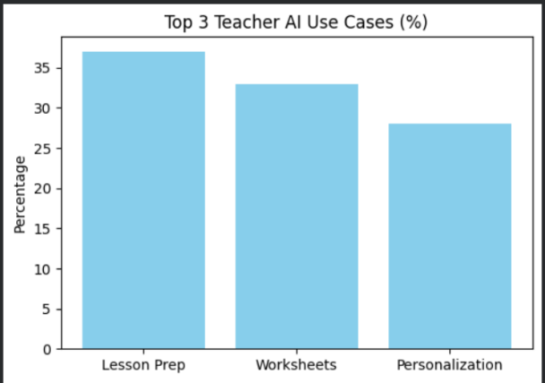
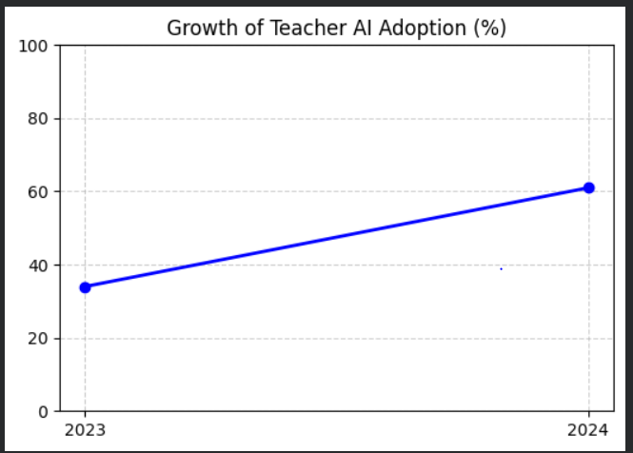
In the era of modernization, Artificial Intelligence becomes an indispensable part of human life that allows humans to make better decisions, streamline the research process, and provide assistance in high-pressure workforces and academic learning environments. Notably, schools decide to implement intelligent systems to support grading systems for teachers and personalized learning for students. In detail, three distinct statistical diagrams showcase the rocket adoption and the diverging ways in which AI is utilized within the educational sector.
Figure 2: Primary AI Applications and Usage Patterns among Educators
Figure 1: Growth of AI Adoption among Educators (2023–2024)
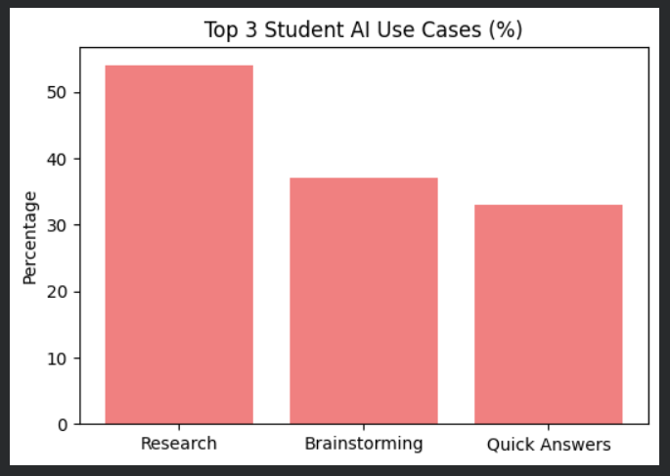
Currently, the significant application of AI into education area is undeniable as illustrated by the three figures above, demonstrating its widespread application in various areas in general and education in particular. In depth, the first figure presents a 27% growth in teacher adoption, rising from 34% in 2023 to 61% in 2024. Next, the second one exhibits percentages of using AI in three distinct categories levels include lesson preparation (37%), worksheets (33%), and personalization (28%). Finally, the last one displays 54% in researching, 37% in brainstorming, and 33% in quick answers respective.
Figure 3: Dominant AI Applications for Academic Tasks among Students
In contrast, the integration of AI into the educational perspective showcases a hot-spot ethical issue.While AI offers stunning systems that solve complex problems including automating administrative tasks and generating adaptive learning paths, a significant concern arises when students completely rely on AI to provide direct answers instead of using it as a potential tool for suggestion and logical reasoning. According to the Stanford AI Index Report in the year 2024, the rocket adoption of AI tools in education has increased students' reliance on automated responses, raising dramatic concerns that excessive dependence on AI may undermine critical thinking and independent problem-solving skills rather than supporting them. Due to above reasons, this report aims to research, analyze, investigate, and propose that AI should be utilized for assisting in students' cognitive development rather than replacing their intellectual efforts..
Part B: The Landscape and Revolution of AI
2.1 The Big Picture: What is AI?
Nowadays, there are diverse definitions of what is truly artificial intelligence. As reported by Andrew Ng in 2016, artificial intelligence refers to a set of techniques that allow machines to learn from data and make intelligent decisions, rather than relying solely on explicit rule-based programming. Furthermore, according to Russel and Norvig (2020), the academic study of AI is systematically categorized into four primary approaches based on whether a system aims to think and act like a human, or think and act rationally.
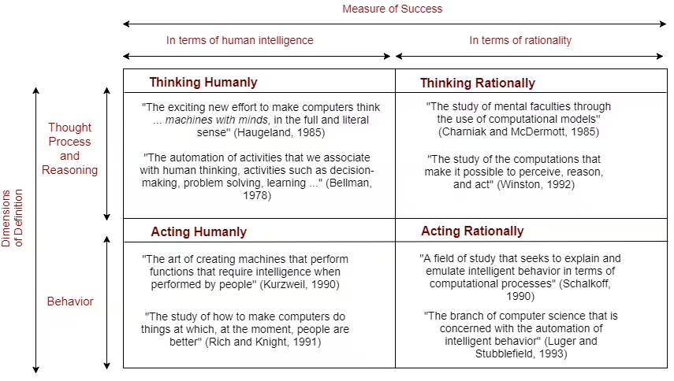
Figure 4: The Four Approaches to Artificial Intelligence (Russel and Norvig, 2020)

During the researching and analyzing phase, “rationally” does not necessarily mean acting like a human, but rather acting "rightly." Besides, a system is rational if it acts to achieve expected outcomes based on the available knowledge and logic. Besides that, the word “humanly” means a benchmark where success is measured by how closely a machine’s performance matches human performance, composed of cognitive biases, emotional responses, and characteristic patterns of error. Thus, the ultimate goal is to attain substantial similarity to human behavior or thought. Specifically, the figure 4 illustrates these definitions against the two focuses of thought versus behavior to categorize the four main approaches to AI:
- Thinking Humanly (The Cognitive Modeling Approach): The first approach focuses on building and validating a computational model by identifying how the human mind reaches conclusions instead of producing correct outputs or observable behavior. By combining psychological knowledge with computer simulations, researchers can determine if the steps taken by the program match the internal mental processes documented in human subjects.
- Acting Human (The Turing Test): The second category evaluates a system’s intelligence based on its ability to exhibit behaviors that are indistinguishable from those of a person. In order to pass this criteria, the machine must successfully utilize natural language processing techniques and automated reasoning to interact with an interrogator, guaranteeing its external behavior cannot be differentiated from a human response.
- Thinking Rationally (The Laws of Thought Approach): For this approach, the goal is to codify "right thinking" using a logical notation by using formal logic and syllogisms, resulting in providing right conclusions based on provided premises. Moreover, the system has to translate informal knowledge into formal terms and use logical inference to derive new information, ensuring that reasoning is demonstrably correct according to established rules of logic.
- Acting Rationally (The Rational Agent Approach): The final approach aims to generate an intelligent agent that achieve the best expected outcomes based on available information. Moreover, this practice prioritizes goal-oriented behavior and autonomous actions, allowing the system to perceive its environment and take the most effective steps to maximize success in sophisticated real-world scenarios.
By understanding four early approaches, this section provides a theoretical basis for evaluating the development of artificial intelligence. Moreover, these provided frameworks have laid the foundation for the various directions have taken over the decades. In the next part, the profound history of artificial intelligence part highlights how these concepts evolved from early philosophical inquiries into the complicated autonomous systems in today's world.
2.2 The Profound History
Since the appearance of electronic computers in the mid-20th century, humans have asked how computers can be programmed to simulate thinking and actions that reduce workflows and adapt to the skyrocketing revolution of technology. Surprisingly, the bold and visionary thinking of early pioneers has opened a gateway to a completely new era of science, transforming abstract theory and mathematical logic into the foundation of artificial intelligence. During the research and analysis phase, the AI revolution is divided into four different phases and each period represents a critical leap in how machines perceive, learn, and interact with the world.
In the early development of Artificial Intelligence, the field was not yet a recognized discipline, but rather a collection of groundbreaking theories from mathematics and biology. In the year of 1943, Warren McCulloch and Walter Pitts examined and proposed first mathematical model of an artificial neuron, proving that even simple networks could compute any logical function and laying the foundation for neural computation.
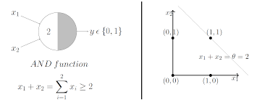
Figure 5: The McCulloch-Pitts Mathematical Model of an Artificial Neuron (1943)
After seven years, in 1950, Alan Turing published his seminal research paper the "Computing Machinery and Intelligence" test, introducing a test that pushed the boundaries of this gestation period and redefined how we evaluate machine intelligence. Then, six years later, John McCarthy, Marvin Minsky, Claude Shannon, and Nathaniel Rochester spent two months studying at Dartmouth College and formally introducing the term “Artificial Intelligence” in six years later. Furthermore, this event served as the official catalyst for the field, generating a core belief that every aspect of learning or intelligence could be so precisely described that a machine could be made to simulate it.
Next, the birth of the word “artificial intelligence” has allowed researchers, scientists, and developers to explore the vast potential of machine reasoning with immense enthusiasm. In particular, the period from 1956 to 1974 is considered as the golden years of optimism which recorded several achievements including:
- The First AI Language and Neural Network (1958): John McCarthy created the primary language for AI research named Lisp while Frank Rosenblatt built the Mark 1 Perceptron, the first computer that could learn to recognize shapes through a biological-like neuron structure.
- ELIZA (The First Chatbot): In the years 1964-1966, Joseph Weizenbaum generated and developed ELIZA, a program capable of natural language conversation. In addition, the first innovative idea indicated the world that machines could simulate human dialogue, specifically acting as a psychotherapist.
- Robot Shakey (1966-1972): Researchers at SRI International built the first mobile robot with the ability to perceive and reason about its surroundings named Shakey

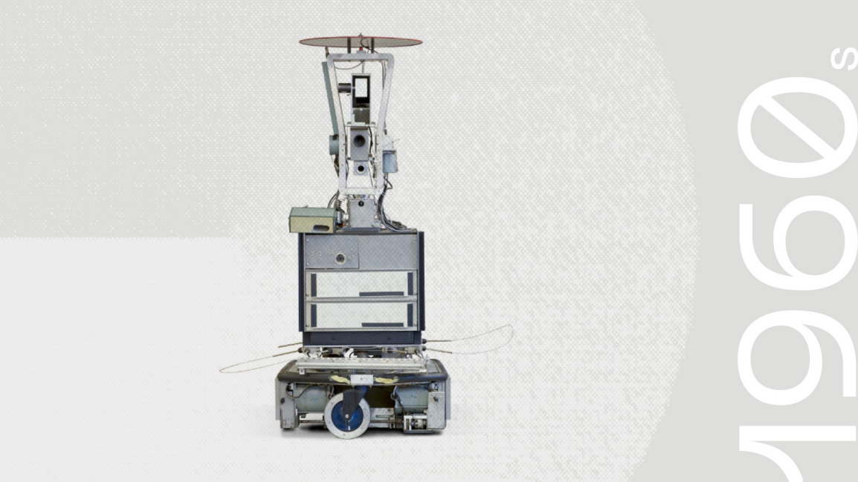
Figure 6: Robot Shakey
Consequently, these outstanding inventions indicate that machines can be programmed to mimic human thinking and behaviors, navigate physical environments, and even learn from visual data. In addition, these historical milestones proved the core components of intelligence including perception, language, and reasoning could be simulated by technology. However, in the mid-1970s, the first golden age has been slowed down due to lack of memory and processing speed. In addition, the gap between high expectations and the technical reality of the time led to the first AI Winter, a period of reduced funding that lasted until new approaches in machine learning emerged
2.3 The Stunning Revolution
Although real-world complex challenges had initially slowed the field's progress during the first AI Winter, human curiosity and the drive for practical solutions led to a completely new road. In the early 1980s, Edward Feigenbaum introduced Expert Systems, which allowed machines to mimic the decision-making abilities of human experts in specific fields such as medicine and finance. As a result, this shift pointed out that AI could provide immense commercial value, moving the technology from theoretical research into the business world. Besides that, Geoffrey Hinton and his colleagues popularized the Backpropagation algorithm eight years later, offering ability to automatically adjust their internal weights and learn from their own errors. Notably, this breakthrough transformation shifted the AI landscape from manually programmed rules to systems that could learn autonomously, paving the way for the massive data-driven revolution of the 21st century.
Thanks to early innovations of Edward Feigenbaum and Geoffrey Hinton, AI was not only no longer just a theoretical dream but also a functional tool with growing potential. Furthermore, these foundational steps ensured that when computing power finally caught up with human ambition in the late 1990s and early 2000s, the field was ready to explode. Specifically, a milestone was achieved in 1997 when IBM's supercomputer, Deep Blue, challenged and surpassed human expertise by defeating world chess champion Garry Kasparov. Furthermore, the stunning event shaked the world that machines could now possess the processing speed necessary to master complex human strategies. By masterfully combining massive computational power with refined algorithm, this era proved that the constraints of the first "AI Winter" had been overcome, setting the stage for the data-driven revolution of the 21st century.
2.4 Current AI Trends
In today’s global landscape, the potential of artificial intelligence is no longer restricted by the technical bottlenecks of the past as it inherited three distinct pillars of innovation developed since the early 2000s, contributing the essential "fuel" and "engine" that drive today’s "Stunning Revolution”:
- The Inheritance of Big Data: Due to the explosion of the Internet and social media, a massive digital archive was generated that provided the "raw fuel" for modern machine learning. In addition, the dramatic increase of users in online platforms has created a continuous stream of real-time interactions, allowing AI models to be trained on diverse human behaviors and languages. As a result, the Big Data technology has empowered current technologies to not only process information but also to predict and adapt to human needs with "stunning" precision.
- The GPU Revolution: The transition of Graphics Processing Units (GPUs) from entertainment tools to AI engines in the late 2000s provided the necessary computing power. By leveraging these processors, it allowed modern AI to process millions of complex calculations simultaneously, drastically reducing the time needed to "train" intelligent systems.
- The Mastery of Deep Learning (2012): Building on the foundations laid in 1986, the breakthrough of Deep Learning in the year 2012 showcased that neural networks could outperform humans in pattern recognition. Currently, developers utilize these cutting-edge techniques in recognizing faces, translating languages instantly, and solving complex academic problems.
The convergence of these pillars has caused AI adoption to skyrocket, with the Stanford AI Index 2024 reporting a surge from 34% to 61% in recent years. Therefore, the rapid integration notes that AI is no longer a futuristic concept but a primary driver of the current digital era.
2.5 Future of AI
As noted by Andrew Ng, "AI is the new electricity," suggesting that artificial intelligence will become an essential part of human life that powers innovation and transformation across all sectors. In the foreseeable future, the next AI generation is expected to move beyond simple automation toward autonomous problem-solving. Particularly, this transformation will focus on Artificial General Intelligence (AGI) and advanced human-machine collaboration, further solidifying its role as the backbone of modern civilization.
Part C: Ethics and Application in AI-Driven Education

